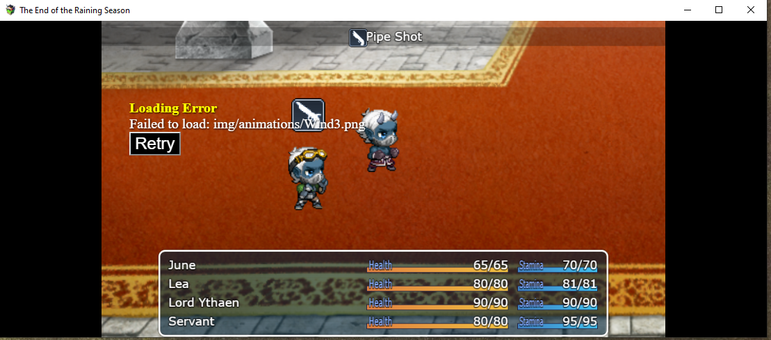

Corrected by copying Wind3.rpgmvp from Tales of Legends

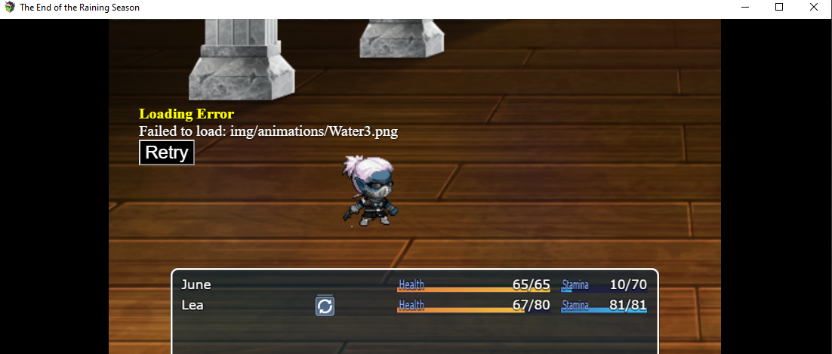


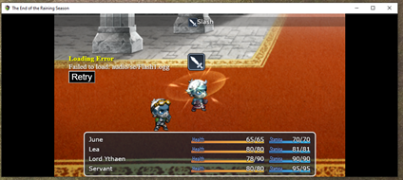


Corrected by copying Flash1.rpgmvo from Tales of Legends

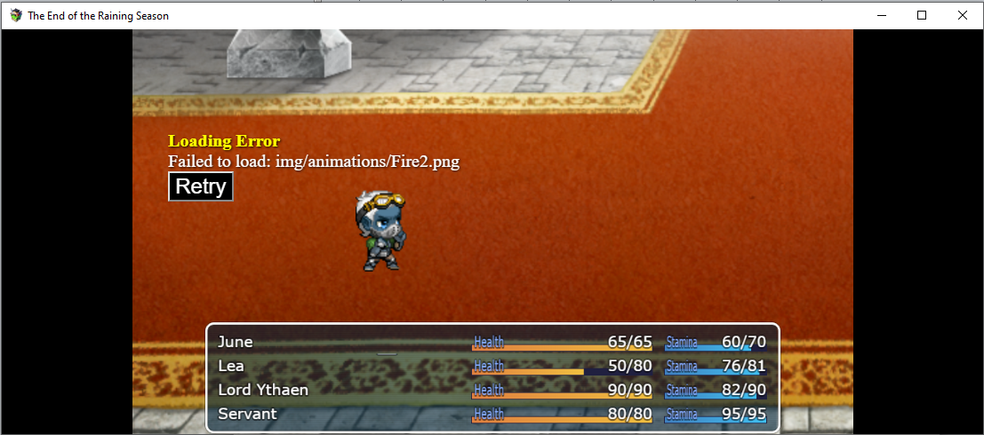

Corrected by copying Fire2.rpgmvp from Tales of Legends

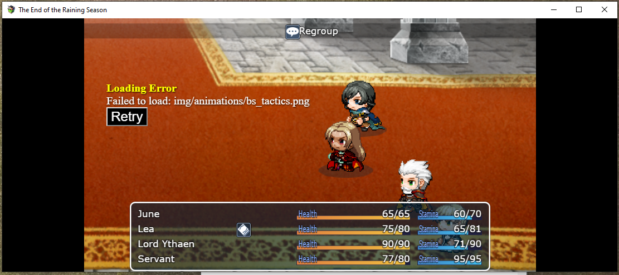

There I'm stucked !
img/animations/bs_tactics

